Command 1: shifting from normal user to root user using sudo su.



Command 2: Creating a folder/directory using mkdir and changing the working directory using cd.



Command 3: Creating 2 empty files using touch and listing them out using ls.

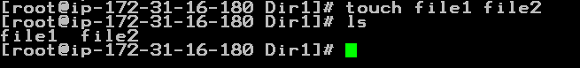

Command 4: Creating a file using visual editor (vi) and viewing its contents

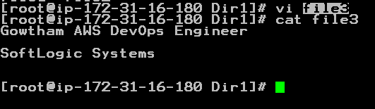

Command 5: Downloading a file from web (wget)

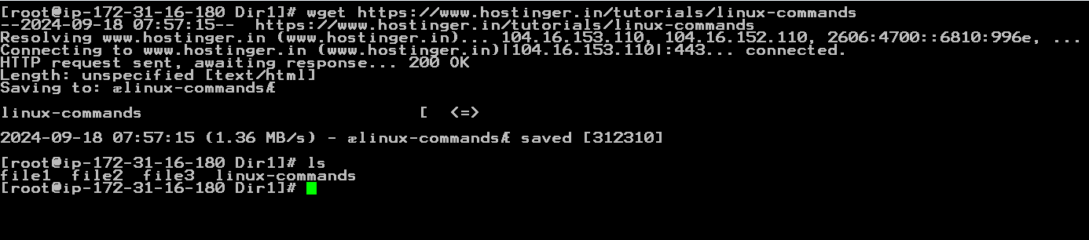

Command 6: Copying files using cp.

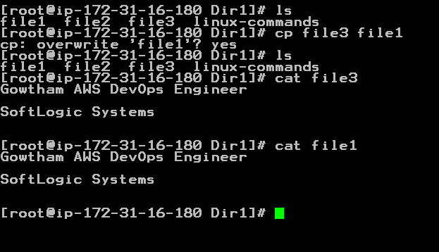

Command 7: Moving file 3 into file 2 using mv.

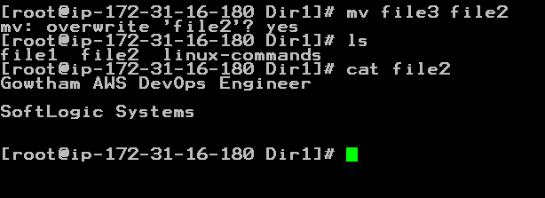

Command 8: Providing read only permission to file 1 and checking it.

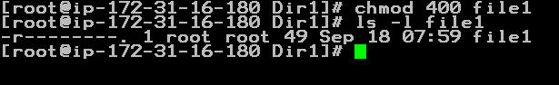

Command 9: changing directory using cd ../ and deleting the directory us rm .

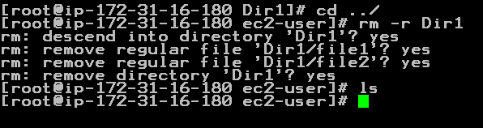

Command 10. History

